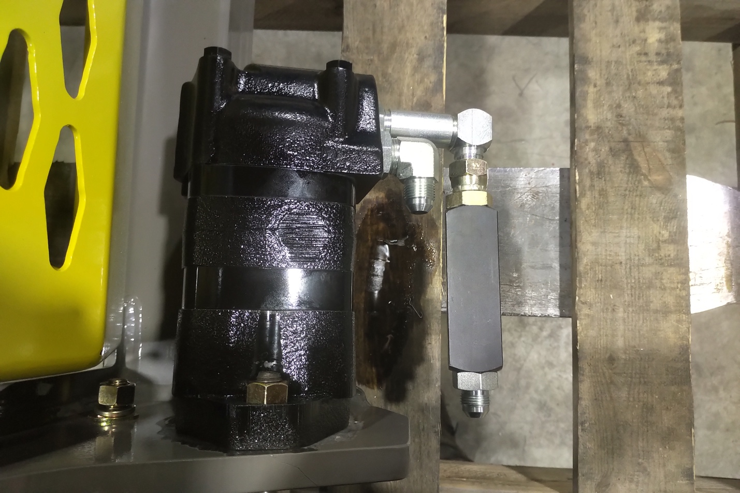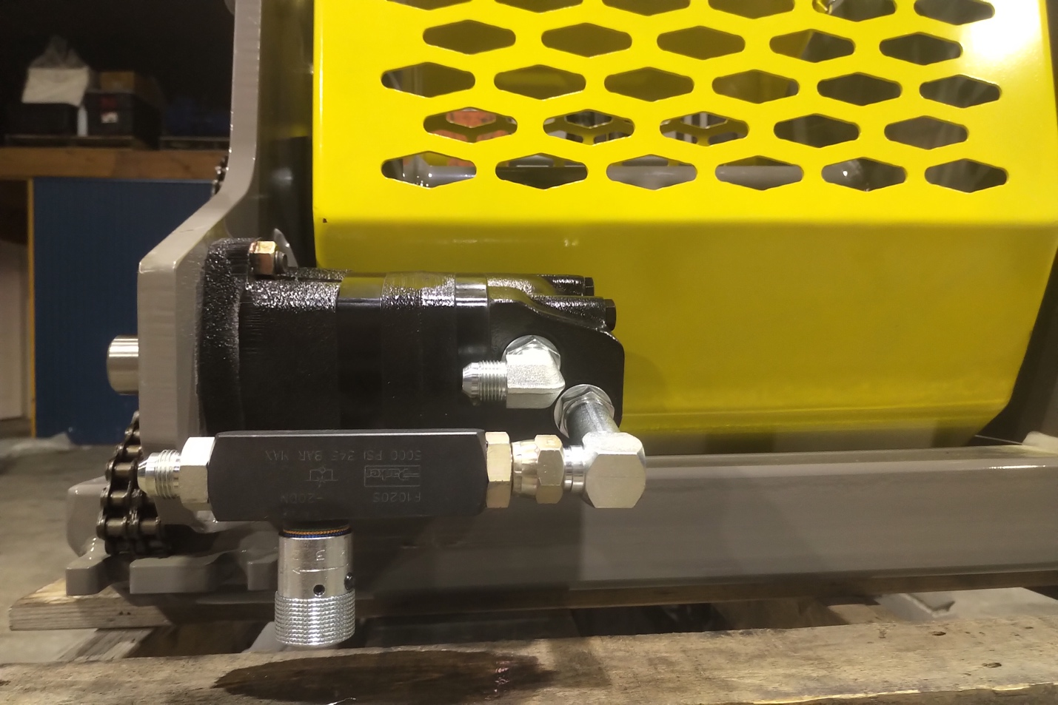
3/32 set screw to unlock and lock knob in position.

Flow control installation for overrunning wireline winches.

Installation of flow control is designed to slow down wireline in the hoist outhaul direction without hindering winch up speed.
This will result in a better controlled down feed in wire.

Tools needed
-7/8 wrench
-oil pan
-spill pads

Installation

Flow control is meant to be installed on the lower motor port in order to control oil flow leaving the motor when spooling wire rope out.
-With machine shut down, locked out and with no load on the winch line, remove the lower -8 hose off the motor. Expect some oil leakage and be prepared accordingly.
-Install Flow control valve on the motor as shown in the photos.
-Re attach -8 JIC hose on the back of the flow control and double check all fittings are tight.
-Operate winch.

Adjustment

Adjustment Knob Is Pre set and has been locked in position. Forcing knob to move without loosening allen key WILL CAUSE DAMAGE TO THE VALVE. (3/32 allen key). It is not recommended to change flow control setting unless further slowing down of the winch is required.
-Flow control has been set to successfully lower and feather 300lbs.

-To Speed up winch on outhaul, turn knob COUNTERCLOCK wise. This is to be done in ¼ turn increments and testing in between. In speeding up the winch, the user must be aware that the winch could start to overrun and is NOT recommended.
-If it is noticed that the winch still wants to overrun with weight or is hard to “feather” load into postion it may be required to SLOW the winch down. This is done by turning the adjustment knob clockwise. This is to be done in ¼ turn increments. Be aware that the knob can be turned to the point that it will stop all oil flow and prevent the winch from turning in one direction.
- After setting winch to desired flow, It is important to snug allen set screw back in to prevent the setting changing or tampering between shifts.

Original Setting is Set to the BLUE RING, #5 on the KNOB.
